## **Write the python program for Vacuum Cleaner problem**

## **AIM**

To implement a Python program for a **2×2 Vacuum Cleaner agent** that moves around and cleans all dirty squares automatically.

## **ALGORITHM**

1. Represent the environment as 4 squares: (0,0), (0,1), (1,0), (1,1).
2. Initialize all squares as **dirty** (False) and start the vacuum at (0,0).
3. While there exists any dirty square:
   1. If the current square is dirty, clean it.
   2. Decide next move based on uncleaned squares:
      1. Move horizontally first if possible, else move vertically.
   3. Update the vacuum’s position and record the path.
4. Repeat until all squares are clean.
5. Print the sequence of moves and cleaning actions.

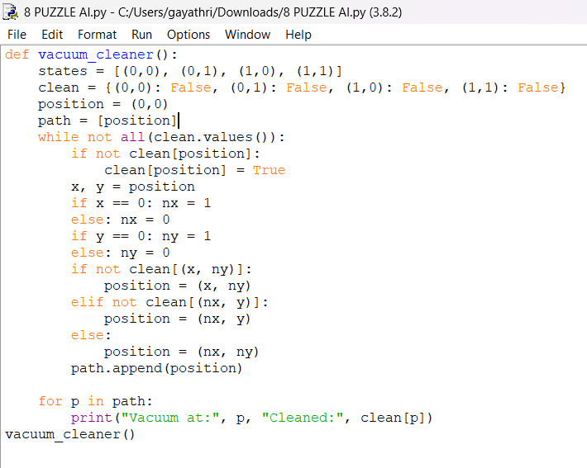

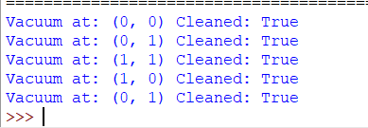

## **RESULT**

The program successfully simulated a vacuum cleaner agent in a 2×2 environment.  
 It visited all squares, cleaned them, and printed the **path and cleaning status**.